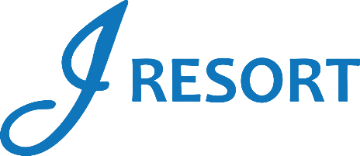
Fridays Cheese & Wine at Afterglow Lounge
Rules and Regulations

- Promotion is happening every Friday starting on January 5th, 2024, from 7:00pm to 9:00pm.
- Starting at 6:30pm, guests who earn 15 Promotional Points during the day, must swipe their card at any Promotional Kiosk Machine to receive a Ticket for a Glass of Wine, and a small Cheese plate.
- Guests must redeem their ticket only at the Afterglow Lounge.
- Tickets can only be redeemed during the Friday earned.
- Guests can only participate 1 time per Friday during this promotion.
- Players can start earning Promotional Points at 12:00am. However, tickets will not start printing until 6:30pm.
- Participation in this promotion grants J Resort permission to utilize any photos taken for Marketing purposes.
- Management reserves all rights to change, alter or cancel this promotion at any time, with or without notice.

