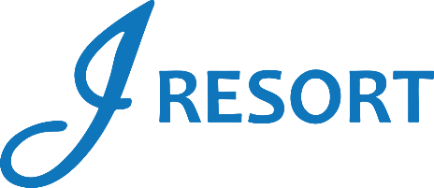
Double Up Delight
Saturday, January 20th, 2024
Rules and Regulations

- Promotion open to all J Rewards members.
- Promotion happening on Saturday, January 20th, 2024, from 12:00am to 11:59pm.
- Starting at 12:00am, members who earn 100 Promotional Points during the day, must swipe their card at any Promotional Kiosk to receive $25 in E-CASH.
- Members can participate a 2nd time if they earn 200 Promotional Points during the day.
- E-CASH will be automatically added to player’s account after participating in the Promotional Kiosk Machine.
- E-CASH will be available for 6 days.
- Guests can participate a maximum of 2 times during this promotion.
- Rules & Regulations are subject to change.
- Participation in this promotion grants J Resort permission to utilize any photos taken for Marketing purposes.
- Management reserves all rights to change, alter or cancel this promotion at any time, with or without notice.

