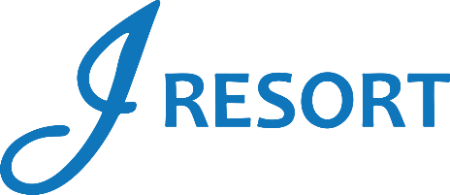
Hanna’s Table Steak & Shrimp E&G
Saturday, April 13th, 2024
Rules and Regulations

- The promotion will take place on Saturday, April 13th, from 11:00 am to 10:00 pm.
- Starting at 11:00 am, members who earn 25 Promotional Points during the day must swipe their card at any Promotional Kiosk Machine to receive a Ticket for a Steak & Shrimp plate at Hanna’s Table.
- Members must redeem their ticket exclusively at Hanna’s Table.
- Tickets can only be redeemed on the day of the promotion.
- Each guest can participate once during this promotion.
- Players can begin earning Promotional Points at 3:00 am. However, tickets will not start printing until 11:00 am.
- Rules & Regulations are subject to change.
- Participation in this promotion grants J Resort permission to use any photos taken for marketing purposes.
- Management reserves all rights to change, alter, or cancel this promotion at any time, with or without notice.

