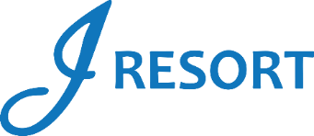
Play Up Bonus
Saturday, June 22nd
Rules and Regulations
- This promotion is open to all J Rewards members.
- The Promotion will be held on Saturday, June 22nd from 3:00am to 11:59pm.
- Members can participate a maximum of 4 times during this promotion if they accumulate the required promotional points.
- After earning the required promotional points, members must swipe their card at any Promotional Kiosk Machine every time and select the promotional image to activate it.
- All members receive the following prizes:
  - $25- E-CASH when they earn 100 promotional points.
  - $35 E-CASH when they earn 300 promotional points.
  - $50 E-CASH when they earn 500 promotional points.
  - $125 E-CASH when they earn 1,000 promotional points.
- Members who participate in this promotion during the 4 levels will receive a total of $235 in E-CASH.
- E-CASH will be automatically added to the player’s account after participating in the promotion through the Promotional Kiosk Machine.
- E-CASH is available for 6 days.
- Rules & Regulations are subject to change.
- Participation in this promotion grants J Resort permission to utilize any photos taken for Marketing purposes.
- Management reserves all rights to change, alter or cancel this promotion at any time, with or without notice.

