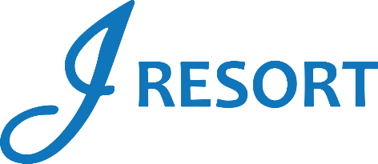
The Great Reno Balloon Race Experience Giveaway
Friday, September 6th & Saturday, September 7th, 2024
Rules and Regulations

- Giveaway will take place on Friday, September 6th & Saturday, September 7th at 7:00pm.
- It is open to all members of the J Rewards Club.

- Starting from August 1st at 3:00am until Saturday 7th at 6:59pm, all members earn 1 drawing ticket for every 10 Promotional Points accumulated. There is no limit to the number of tickets members can earn.
- On Friday, September 6th & Saturday, September 7th starting at 3:00pm, members can start activating their tickets into the virtual drawing drum by swiping their card on any Promotional Kiosk machine.
- Giveaway will take place at 7:00pm each day.

- The marketing team will select 1 winner each day who will receive a Hot Air Balloon ride for 2, VIP parking, and access to the J Resort VIP Tent that includes fully catered breakfast, and other VIP incentives during The Great Reno Balloon Race 2024.
- The winner selected on Friday must attend The Great Reno Balloon Race 2024 on Saturday.
- The winner selected on Saturday must attend The Great Reno Balloon Race 2024 on Sunday.

- Winners must be present to claim their prize and have 2 minutes to do so.
- If a winner is not present, Marketing will select another winner.
- Winners can only win once during this promotion.
- Prizes are not transferable, redeemable for cash or exchangeable for any other prize.
- Winners are responsible for attending the event on time and on the specified day as stated on the certificate.
- Rules & Regulations are subject to change.

- In the event of a technical difficulty that impedes the drawing system from functioning as intended, the following procedure will be instated. The marketing employee will retrieve a report of all players who activated their entries, select a Hot Seat, and if the Hot Seat player has activated the entries, this player will be the winner.
- Participation in this promotion grants J Resort permission to utilize any photos taken for Marketing purposes.
- Management reserves all rights to change, alter, or cancel this promotion at any time, with or without notice.

