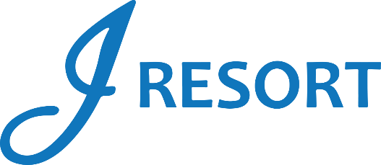
Let’s Do Something Nice
Drawings
Saturday, October 5th, 2024
Rules and Regulations

- Event takes place on Saturday, October 5th, 2024, from 5:00pm to 8:00pm.
- Event is open to every member of the J Rewards Club.
- Members earn 1 Drawing Ticket for every 1 Promotional Point they earn during the day starting at 3:00am.
- Starting at 3:00pm, members can start activating their tickets into the drawing drum by swiping their card on any Promotional Kiosk machine.
- Starting at 5:00pm, and for every 10 Minutes, there will be 1 virtual drawing winner who is going to receive $300 in E-CASH and pick another member who will receive $100 in E-CASH.
- There will be 38 winners during this event.
- Winners must be present to win.
- Winners will have 2 minutes to claim their prize.
- Winners will have 1 minute to pick another member.
- Winners must be part of the J Rewards club in order to receive the prize.
- Winners will claim their prizes at the Marketing Table next to Guest Services.
- Winners can be called a maximum of 2 times during this event.

- E-CASH will be available for 6 days.
- Guests Social Security number will need to be on file to collect any prize.
- Guests are responsible for all applicable taxes.
- Drawing drum will be emptied at the end of the event.
- Rules & Regulations are subject to change.

- In the event of a technical difficulty that impedes the drawing system from functioning as intended, the following procedure will be instated. The marketing employee will retrieve a report of all players who activated their entries, select a Hot Seat, and if the Hot Seat player has activated the entries, this player will be the winner. If the first procedure can’t be implemented, the marketing employee will select all winners through the hot seat system.
- Participation in this promotion grants J Resort permission to utilize any photos taken for Marketing purposes.
- Management reserves all rights to change, alter or cancel this promotion at any time, with or without notice.

