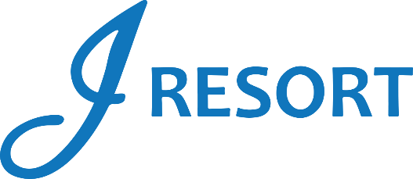
Nevada Day Extravaganza
Friday, October 25th, 2024
Rules and Regulations

- Event takes place on Friday, October 25th, 2024, from 5:00pm to 8:00pm.
- Event is open to every member of the J Rewards Club.
- Guests earn 1 Drawing Ticket for every 1 Promotional Point they earn during the day starting at 3:00am.
- Starting at 3:00pm, members can start activating their tickets into the drawing drum by swiping their card on any Promotional Kiosk machine.
- Starting at 5:00pm, and for every 5 Minutes, there will be 1 virtual drawing winner who is going to receive $100 in E-CASH and select a Nevada memorabilia basket.
- There will be 40 winners during this event.
- Winners must be present to win.
- Winners will have 2 minutes to claim their prize.
- Winners will claim their prizes at the Marketing Table next to Guest Services.
- Winners can be called a maximum of 2 times during this event.

- E-CASH will be available for 6 days.
- Memorabilia prizes are not transferable, redeemable for cash or exchangeable for any other prize.
- Memorabilia prizes are final.
- Guests Social Security number will need to be on file to collect any prize.
- Guests are responsible for all applicable taxes.
- Drawing drum will be emptied at the end of the event.
- Rules & Regulations are subject to change.

- In the event of a technical difficulty that impedes the drawing system from functioning as intended, the following procedure will be instated. The marketing employee will retrieve a report of all players who activated their entries, select a Hot Seat, and if the Hot Seat player has activated the entries, this player will be the winner. If the first procedure can’t be implemented, the marketing employee will select all winners through the hot seat system.
- Participation in this promotion grants J Resort permission to utilize any photos taken for Marketing purposes.
- Management reserves all rights to change, alter or cancel this promotion at any time, with or without notice.

