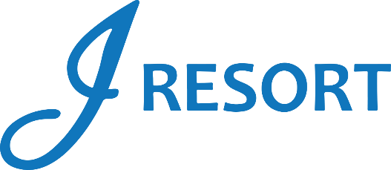
Black Friday Blowout
Friday, November 29th, 2024
Rules and Regulations

- Event takes place on Friday, November 29th, 2024, from 3:00pm to 8:00pm.
- Event is open to every member of the J Rewards Club.
- Members earn 1 drawing ticket for every 10 Promotional Points earned throughout the day, starting at 3:00am.

- Starting at 1:00pm, members can start activating their tickets into the drawing drum by swiping their card on any Promotional Kiosk machine.
- Starting at 3:00pm, and every 15 minutes, there will be one winner selected from the virtual drawing drum who is going to receive an electronic prize, with a total of 21 prizes awarded.
- Once a winner is called, they will choose a Mini Supermarket Handcart, each of which contains an envelope revealing their prize.

- White Gold Members who are called as winners will also receive a bonus of $100 in E-CASH.
- Black Gold Members who are called as winners will also receive a bonus of $200 in E-CASH.
- Ultimate Gold Members who are called as winners will also receive a bonus of $300 in E-CASH.

- Winners must be present to win.
- Winners will have 2 minutes to claim their prize.
- Winners must be part of the J Rewards club in order to receive the prize.
- Winners will claim their prizes at the Marketing Table next to Guest Services.
- Winners can be called a maximum of 2 times during this event.
- Members who earn more than 20 drawing tickets will receive 100 free entries for the Winning Succession Finale Night happening the next day, Saturday, November 30th.

- Electronics are not transferable, redeemable for cash or exchangeable for any other prize.
- Electronics are final.
- E-CASH will be available for 6 days.
- Guests Social Security number will need to be on file to collect any prize.
- Guests are responsible for all applicable taxes.
- Drawing drum will be emptied at the end of the event.
- Rules & Regulations are subject to change.

- In the event of a technical difficulty that impedes the drawing system from functioning as intended, the following procedure will be instated. The marketing employee will retrieve a report of all players who activated their entries, select a Hot Seat, and if the Hot Seat player has activated the entries, this player will be the winner. If the first procedure can’t be implemented, the marketing employee will select all winners through the hot seat system.
- Participation in this promotion grants J Resort permission to utilize any photos taken for Marketing purposes.
- Management reserves all rights to change, alter or cancel this promotion at any time, with or without notice.

