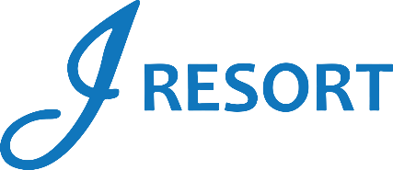
NYE The Time Traveler’s Ball Drawings
Tuesday, December 31st, 2024
Rules and Regulations

- Event takes place on Tuesday, December 31st, 2024, from 9:00pm to 1:00am.
- Event is open to every member of the J Rewards Club.
- Members earn 1 Drawing Ticket for every 1 Promotional Point they earn starting Friday, December 27th at 3:00am.
- On Tuesday, December 31st starting at 7:00pm, members must swipe their J Rewards card at any Promotional Kiosk Machine, go to promotions, select the “NYE Time Traveler’s Ball” image and select “yes” to activate their tickets into the virtual drawing drum.

Virtual Drawings:
- Starting at 9:00pm, and for every hour until 12:00pm (9pm-10pm-11pm-12pm), there will be 1 winner who will receive $1,000 in E-CASH (4 Winners).
- Starting at 9:15pm, and for every 15 minutes until 12:45pm, there will be 1 winner who will receive $500 in E-CASH (12 Winners). (NO $500 E-CASH winners at 9pm-10pm-11pm & 12pm).
- At 1:00am, there will be 1 winner who will receive $2,025 in Cash, and 1 winner who will receive $2,025 in E-CASH. (2 Winners).

- Winners must be part of the J Rewards club in order to receive the prize.
- Winners can win once between the 9:00pm and 12:45am drawings, but all members are eligible to win again at the 1:00am drawing.
- Members can win a maximum of two times during this event.
- Winners must be present to win.
- Winners will have 2 minutes to claim their prize.
- Winner will claim their prizes at the Marketing Podium located next to Guest Services.

- E-CASH will be available for 6 days.
- Guests Social Security number will need to be on file to collect any prize.
- Guests are responsible for all applicable taxes.
- Drawing drum will be emptied at the end of the event.
- Rules & Regulations are subject to change.

- In the event of a technical difficulty that impedes the drawing system from functioning as intended, the following procedure will be instated. The marketing employee will retrieve a report of all players who activated their entries, select a Hot Seat, and if the Hot Seat player has activated the entries, this player will be the winner. If the first procedure can’t be implemented, the marketing employee will select all winners through the hot seat system.
- Participation in this promotion grants J Resort permission to utilize any photos taken for Marketing purposes.
- Management reserves all rights to change, alter or cancel this promotion at any time, with or without notice.

