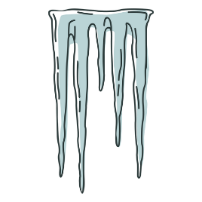

Frost Free Gear Wednesdays

January 2025

Rules and Regulations

* Promotion open to all J Rewards members.

The promotion begins on Wednesday, January 8th, and runs every Wednesday of the month thereafter, starting at 3:00 AM and continuing while supplies last.

* Starting at 3:00am, members who earn **30** Promotional Points during the day must swipe their card at any Promotional Kiosk Machine to receive a ticket to redeem at Guest Services for the **Frost Free Gear** of the week.
* Members must redeem their tickets at Guest Services.
* Tickets can only be redeem during the Wednesday earned.
* Members can participate only once during this promotion.
* Promotion runs while supplies last.
* Limited to 100 items each week.
* Members start earning Promotional Points at 3:00am.
* Gifts are not transferable, redeemable for cash or exchangeable for any other prize.
* Gifts are final.
* Rules & Regulations are subject to change.
* Participation in this promotion grants J Resort permission to utilize any photos taken for Marketing purposes.
* Management reserves all rights to change, alter or cancel this promotion at any time, with or without notice.