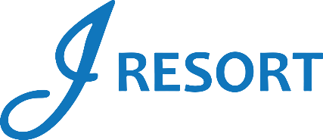
The Ultimate Fan Zone Drawings
Sunday, February 9th, 2025
Rules and Regulations

- This promotion is exclusively for invited guests of the Ultimate Fan Zone party.
- Drawings will take place during the event at the Ballroom.

Drawing Ticket Details
- Each invited guest will receive one free drawing ticket for the promotion.
- Guests must print their tickets by swiping their J Rewards Cards at any Promotional Kiosk Machine.
- Tickets will be available to print starting Saturday, February 8th, 2025, at 3:00am.
- Printed tickets must be deposited in the Gold Drawing Drum located at Guest Services.

Additional Tickets
- Invited guests can earn extra tickets for every 50 Promotional Points earned beginning Saturday, February 8th, 2025, at 3:00am.
- Additional tickets must also be printed at the Promotional Kiosk Machines and deposited in the Gold Drawing Drum at Guest Services.

- On Sunday, February 9th, the drawing drum will be moved to the Ultimate Fan Zone party’s welcome table at 2:00pm.

Drawing Sessions
There will be four drawing sessions during the event:
- End of the 1st Quarter
- At Halftime
- End of the 3rd Quarter
- End of the Game

Prizes
- Five winners per session will receive $350 in E-CASH.
- E-CASH will be available for six days.
- A total of 20 winners will be selected during the event.
- Winners must have a J Rewards Card to claim a prize and must be present to win.
- Winners will have two minutes to claim their prize.
- If a winner is not present, another name will be drawn.
- Each guest may win only once during the event.

Additional Rules
- The prize schedule is based on 150 unique guests. J Resort reserves the right to modify the schedule if fewer than 150 guests participate.
- The drawing drum will be emptied after the final session.
- Guests must have a valid Social Security number on file to collect any prize.
- Winners are responsible for any applicable taxes.
- Participation grants J Resort permission to use any photos taken for marketing purposes.
- Rules and regulations are subject to change.
- Management reserves the right to modify or cancel the promotion at any time, with or without notice.

